**KARUNA**

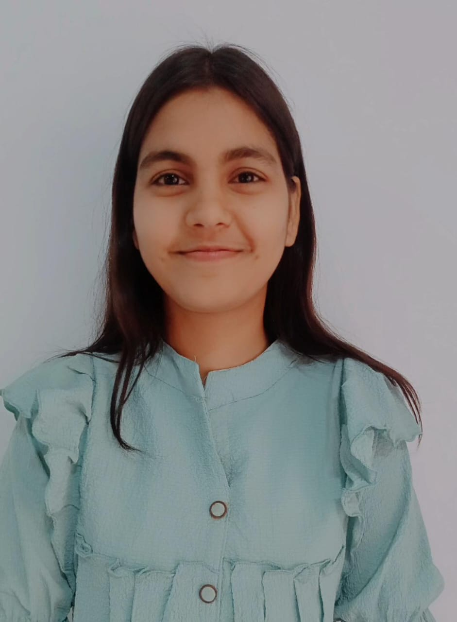

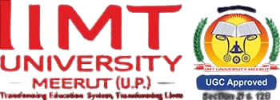

B.TECH(CSE)

+91 9634112518 |linkedin.com/in/Karuna Singh-087477314

[kanusingh616@gmail.com](mailto:kanusingh616@gmail.com)

**CAREER OBJECTIVE:**

A 2027 Bachelor of Technology (B.tech) graduate with a focus on Web Development from IIMT UNIVERSITY in Greater Noida. Aspiring computer science graduate, proficient in creating dashboards and continues to learn and develop in the ever-changing field of computers, would like to contribute to cutting-edge technical solutions. Competent with excellent leadership, communication, problem-solving, and decision-making abilities.

**PROFESSIONAL SUMMARY:**

Bachelor of Technology (B.Tech) 3rd year student skilled with a solid background in Web Development and Python Programming because Python, with its versatile frameworks like Django and Flask, is an excellent choice for building dynamic and interactive web applications.

Acknowledged for having coordination, empathy, and interpersonal effectiveness. Works well with people, communicates well, and takes advantage of opportunities to grow. demonstrates initiative in decision-making and problem-solving.

**EDUCATIONAL QUALIFICATION:**

|  |  |  |
| --- | --- | --- |
| 2023-2026 | IIMT UNIVERSITY , Greater Noida.   * Bachelor of Technology (B.tech)   Semester1(9.00SGPA)  Semester2(8.62SGPA)  Semester3(8.25SGPA) |  |
|  |  |  |
| 2021 - 2023 | **Sunrise Public School CBSE Board.**   * Senior School Certificate Examination, 2022 (94.4%). |  |
| 2018 - 2020 | **Sunrise Public School CBSE Board.**   * Secondary School Examination, 2020 (78.2%). |  |

**SKILLS:**

|  |  |  |  |
| --- | --- | --- | --- |
| **Technical Skills (Hard skills)** | **Skills Learned** | **Soft Skills** | **Skills Learned** |
| Programming Languages & Software development tools | Basics of C, Python; Git & GitHub basics, Code editors etc. | Business Communication Skills. | Writing code comments, Documentation, Email etiquette, Presentation of technical projects etc. |
| Web Development | HTML, CSS | Team work & Problem-Solving Skills. | Group Project, Team collaboration, Critical Thinking & Decision Making etc. |
| Operating system | Basis of operating system and Type of scheduling etc. | Time Management & Adaptability Skills. | Meeting Deadlines, Multi-Tasking, Quick Learner, Working under pressure etc. |
| Data Structures & Algorithms | Basis of Arrays, Linked lists, stacks, queues, searching & sorting algorithms. | Leadership & Work Ethic | Organizing Events, Team Lead in Projects, Discipline, Accountability, Reliability, Willingness to learn etc. |

**ACHIEVEMENTS/AWARDS:**

* Won in **Melody Junction**  organised by IIMT University in 2025.
* Won in Verse Voyage organised by IIMT University in 2025.
* Certification in IOT module1 and module 2.
* NPTEL Online Certification- Programming in Java | Indian Institute of Technology Kharagpur| Jan-Apr| Elite certificate.
* Completed Deloitte Cyber Job Simulation on Cybersecurity – July 2025 (via forage).
* Completed AWS Architecture Virtual Job Simulation – July 2025(via Forage).
* Completed Basics of Python course by UniAthena International Qualifications , UK- July 2025.
* Participated in National Students Paryavaran Competition (NSPC 2025) organized by Ministry of Education & Environment, Govt. of India.

|  |  |
| --- | --- |
| Address: | Noida |
| Father’s Name: | Mr. RajKumar |
| Date of Birth: | 30/08/2005 |
|  |  |

**LANGUAGES**

* **Hindi**
* **English**